**DOKUMEN** **KEY PERFORMANCE**

Almira Rahma Sabita

|  |  |  |
| --- | --- | --- |
| No | Job Description | Performance |
| 1 | Membuat pertanyaan observasi | 80% |
| 2 | Konsultasi dengan client | 10% |

Mochammad Faisal Rahman

|  |  |  |
| --- | --- | --- |
| No | Job Description | Performance |
| 1 | Membuat Jadwal Observasi | 100% |
| 2 | Membuat jadwal pertemuan dengan client | 100% |

Nadia Nur Zulfa

|  |  |  |
| --- | --- | --- |
| No | Job Description | Performance |
| 1 | Membuat pertanyaan observasi | 80% |
| 2 | Membuat data kebutuhan dokumen | 10% |

Wira Tamtama Aditya Saputra

|  |  |  |
| --- | --- | --- |
| No | Job Description | Performance |
| 1 | Membuat Jadwal Observasi | 100% |
| 2 | Memproses data client | 10% |

Malang, 24 Februari 2021

Disetujui oleh:

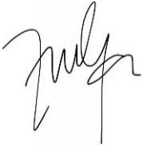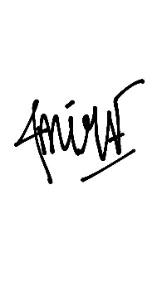

(Almira Rahma) (M. Faisal Rahman) (Nadia Nur Zulfa) (Wira Tamtama)